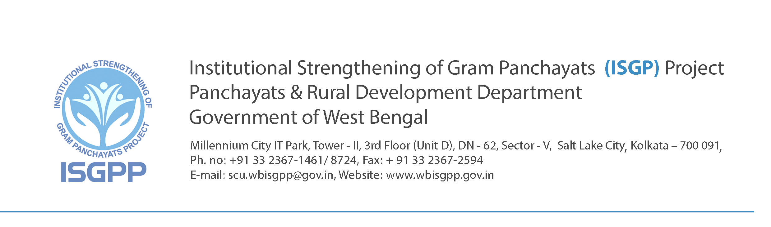
No. 983/ISGPP/23C-1/(CB)/18 Pt I Dated: 26.08.2014

Notification for Publication of Panel of Eligible Candidates for Temporary Engagement of Software Developer (2 posts), Web Developer-cum-Designer (2 posts) and Assistant Programme Support Associate (7 posts) on Contract in the ISGP Project

1. With reference to the advertisement of the ISGP Project of WBSRDA published under
Notification No. 752/ISGP/20E-1/(EP)/14 dated 30.06.2014 for the purpose of temporary engagement of Software Developer (2 posts), Web Developer-cum-Designer (2 posts) and Assistant Programme Support Associate (7 posts) on contract in the ISGP Project of Panchayats & Rural Development Department and applications received in response to the advertisement, with reference to the Interview-cum-Personality Tests held at Office of the ISGP Project, Salt Lake on 19/08/2014 and 20/08/2014 and with approval of competent authorities in P&RD Deptt., this is to notify the Panel of Eligible Candidates as shown at Annexure-1 for information of all concerned. The approved Panel of Eligible Candidates has been prepared on the basis of Interview-cum-Personality Tests and in terms of the eligibility criteria published by this organization in this regard.

2. Engagement on contract in terms of the Notifications No.752/ISGP/20E-1/(EP)/14 dated 30.06.2014 will be issued from top of the empanelled candidates on the basis of rank as per requirement.

3. The Panel of Eligible Candidates being hereby published will remain valid till 31.12.2015 or premature closure of the project, whichever is earlier.

4. Publication of this Panel of Eligible Candidates and inclusion of the name of any candidate in the Panel does not imply any assurance on the part of this organisation to offer engagement, which will depend on actual requirement of the ISGP Project.

5. No request for preference in the matter of place of posting shall be entertained and decision of the ISGP Project authority in this regard shall be final.

Project Manager, ISGPP and
Joint Secretary to the Govt. of West Bengal
Panchayats & Rural Development Department

Annexure: 1

Ref. No. : No. 983/ ISGPP/23C-1/(CB)/18 Pt I Dated: 26.08.2014

Panel of Eligible Candidates for Temporary Engagement on contract under ISGP Project
(Ref: Notification No. 752/ISGPP/20E-1/(EP)/14 dated 30.06.2014 )
[Prepared on the basis of interview & personality test]

Name of Post | Software Developer
Number of Posts | 02
 | No suitable candidate has been found

Name of Post |  | Web Developer-cum-Designer
Number of Posts |  | 02
Total Number of Empanelled Candidates |  |  | 03
Rank | Name of Empanelled Candidate with ID No.
1 | Prosenjit Bhaumik (ID No.: WD - 01)
2 | Pratyush Kumar Mishra (ID No.: APSA - 21)
3 | Hasanujjaman Rahman (ID No.: WD - 03)

Name of Post |  | Assistant Programme Support Associate
Number of Posts |  | 07
Total Number of Empanelled Candidates |  |  | 11
Rank | Name of Empanelled Candidate with ID No.
1 | Hasanujjaman Rahaman (ID No.: APSA - 33)
2 | Pratyush Kumar Mishra (ID No.: APSA - 21)
3 | Subhrajyoti Sahoo (ID No.: APSA - 17)
4 | Avijit Das (ID No.: APSA - 06)
5 | Jay Kumar Dhar (ID No.: APSA - 22)
6 | Mrinmay Choudhury (ID No.: APSA - 37)
7 | Sweta Bharti (ID No.: APSA - 04)
8 | Subrata Samanta (ID No.: APSA - 29)
9 | Tapan Kumar Barik (ID No.: APSA - 01)
10 | Tapan Kumar Ghosh (ID No.: APSA - 12)
11 | Avijit Sarkar (ID No.: APSA - 16)

Project Manager, ISGPP and
Joint Secretary to the Govt. of West Bengal
Panchayats & Rural Development Department

